WEDE5020

MATTHEW GEORGE TERBLANCHE

ST10488562

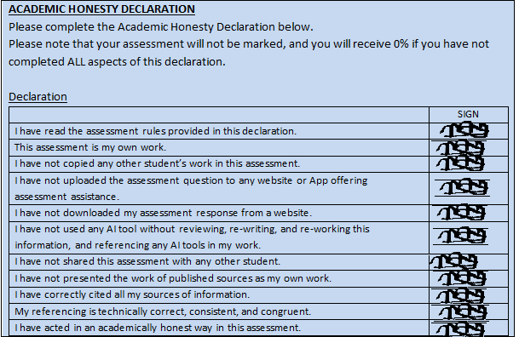

# TABLE OF CONTENTS

Contents

TABLE OF CONTENTS 2

1.Organisation Overview 3

2. Website Goals and Objectives 3

3. Current Website Analysis 3

4. Proposed Features 4

5. Design and User Experience 4

6. Technical Requirements 5

7. Timeline 5

8. Budget 6

Reference List 7

# 1.Organisation Overview

**Name**: Trueform Gym

**History**: Trueform Gym was established in 2018 and is a premium health and fitness centre.The centre specialises in personalised training programs and group classes.It has now spread to three locations,one in Uitenhage,Despatch and Port Elizabeth and has built a reputation as a reliable gym that equips all members with most state of the art facilities that can be afforded to them.

**Mission Statement**: Empower members to achieve all the health and fitness goals at affordable prices.

**Vision Statement**: To foster an increased standard of physical and mental health for all members.

**Target Audience**: Teens and Adults aged 16-50 that are seeking to better the physical and mental health.

# 2. Website Goals and Objectives

**Goals**:

* Increase memberships by 40%
* Streamline class bookings and personal training sessions
* Building an online community through member success stories

**KPIs**:

* Reduction in bounce rate
* Growth in social media engagement
* Increase in monthly class bookings via the website

# 3. Current Website Analysis

**Strengths**:

* Strong branding
* High-quality gym photography
* Clear service descriptions

**Weaknesses**:

* No online booking system
* Poor mobile navigation
* Unresponsive links

# 4. Proposed Features

* Multiple membership plans
* Personal trainer profiles
* Blogs and Resources
* Help section

# 5. Design and User Experience

**Colour Scheme**:

* Bold red(#FF2E2E) used for the buttons
* Black (#333) used for header and background
* White(#FFFFFF) used for text and background
* Light Gray(#ccc) used for form input borders to maintain a modern design

**Typography:**

* Font-family: Arial, sans-serif
* Heading: Style with bold text to emphasize the section titles

**Layout:**

* Header- This contains the logo,navigation bar, and a join us button
* Sections- Every section is styled with min-height:100vh for them to span the full viewport height
* Footer- This includes the copyright information and the social media links of the business

**Wireframes:**

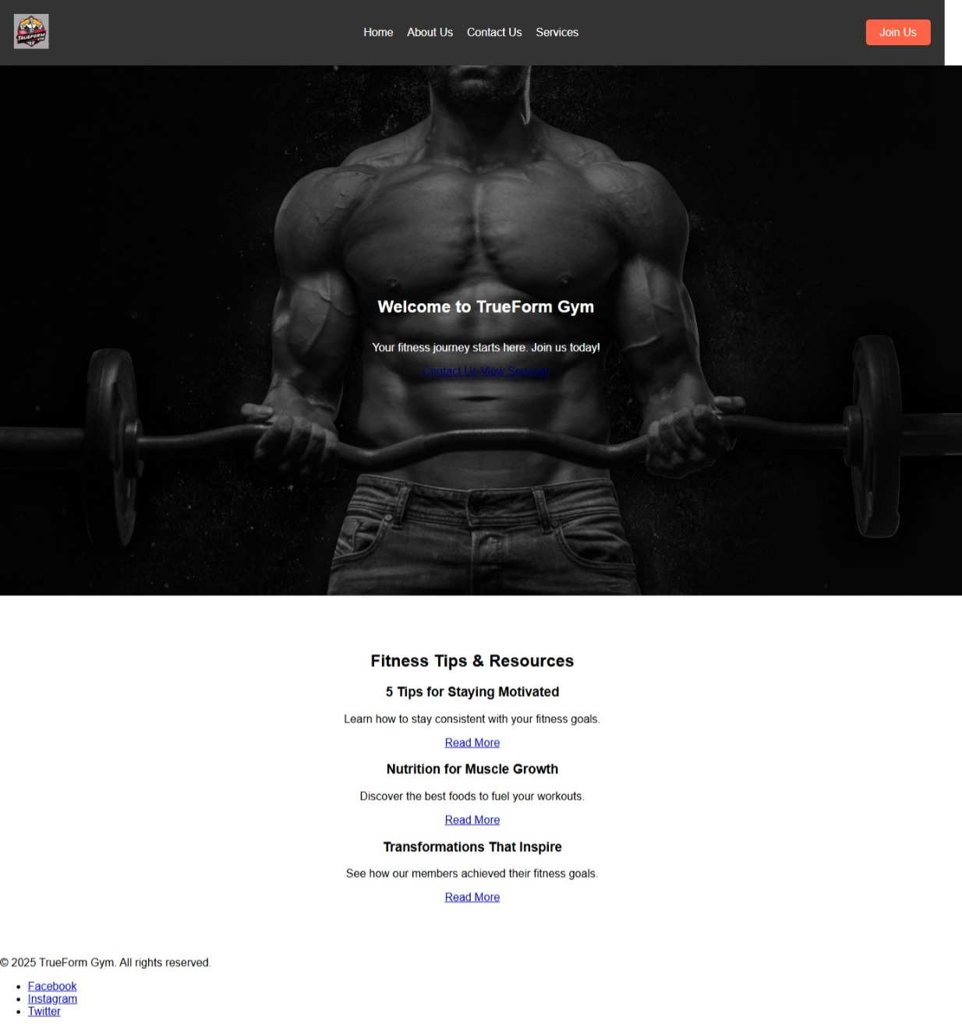

# 6. Technical Requirements

**Hosting**: HostAfrica

**Booking System**: Mindbody API

**CMS**: Wordpress

**Languages**: HTML to structure the webpage and its content, CSS to style the website and JavaScript to make the website interactive.

# 7. Timeline

**Week 1-2**: Research for part 1

**Week 3-6**: Doing part 1, Pre submission, Submitting part 1

**Week 7-10**: Research for part 2, Doing part 2

**Week 11-12**: Submitting part 2

# 8. Budget

**Development**: R3500

**Hosting/Maintenance**: R4320/year

**Marketing**: R10000

**Total**: R17820

**Github Repository**: <https://github.com/Tyrb01/wede5020>

# Reference List

1. **Exercise.com** (2023) *Best Gym KPI Metrics to Track in 2023*. Available at: <https://www.exercise.com/grow/best-gym-kpi-metrics/> (Accessed: 10 March 2025).
2. **HostAfrica** (2023) *Web Hosting Prices in South Africa*. Available at: <https://hostafrica.co.za/web-hosting/> (Accessed: 18 March 2025).
3. **HubSpot** (2020) *The Ultimate Guide to KPIs*. Available at: [https://cdn2.hubspot.net/hubfs/2527762/KPI%20Week/KPI-Ebook.pdf](https://cdn2.hubspot.net/hubfs/2527762/KPI%2520Week/KPI-Ebook.pdf) (Accessed: 5 March 2025).
4. **Kinsta** (2023) *What is a Content Management System (CMS)?* Available at: <https://kinsta.com/knowledgebase/content-management-system/> (Accessed: 20 February 2025).
5. **Lukas** (2018) *Man Holding Barbell* [Photograph]. Pexels. Available at: <https://www.pexels.com/photo/man-holding-barbell-1431282/> (Accessed: 15 February 2025).
6. **New Perspective Studio** (2022) *What is the Cost of Creating a Website in South Africa?* Available at: <https://www.newperspectivestudio.co.za/wp/what-is-the-cost-of-creating-a-website-in-south-africa/> (Accessed: 15 March 2025).
7. **World Wide Web Consortium (W3C)** (2011) *Cascading Style Sheets Level 2 Revision 1 (CSS 2.1) Specification*. Available at: <https://www.w3.org/TR/CSS2/> (Accessed: 25 February 2025).
8. **World Wide Web Consortium (W3C)** (2014) *HTML5: A vocabulary and associated APIs for HTML and XHTML*. Available at: <https://www.w3.org/TR/html5/> (Accessed: 5 March 2025).
9. **World Wide Web Consortium (W3C)** (2014) *WAI-ARIA 1.1: Accessible Rich Internet Applications*. Available at: <https://www.w3.org/TR/wai-aria-1.1/> (Accessed: 10 March 2025).
10. **World Wide Web Consortium (W3C)** (2018) *CSS Flexible Box Layout Module Level 1*. Available at: <https://www.w3.org/TR/css-flexbox-1/> (Accessed: 15 March 2025).
11. **World Wide Web Consortium (W3C)** (2018) *CSS Transitions Level 1*. Available at: <https://www.w3.org/TR/css-transitions-1/> (Accessed: 18 March 2025).
12. **World Wide Web Consortium (W3C)** (2018) *Web Content Accessibility Guidelines (WCAG) 2.1*. Available at: <https://www.w3.org/TR/WCAG21/> (Accessed: 18 March 2025).
13. **World Wide Web Consortium (W3C)** (2021) *CSS Grid Layout Module Level 1*. Available at: <https://www.w3.org/TR/css-grid-1/> (Accessed: 12 March 2025).